Media Toolkit:
Assessing Telehealth Experiences to
Advance Health Equity
for People with Disabilities in Georgia in a Post-COVID-19 Era

Presented by Morehouse School of Medicine National Center for Primary Care
In partnership with United Health Foundation

The Morehouse School of Medicine (MSM) National Center for Primary Care (NCPC) completed a study titled “Assessing Telehealth Experiences to Advance Health Equity for People with Disabilities in Georgia in a Post-COVID-19 Era”.

This toolkit is available as a resource to provide an overview of the study and share the findings with your community. Please reach out to Mitchell A. Blount (mblount@msm.edu) if you have any questions.

Study Description:
MSM and NCPC have been diligently working to advocate for and provide resources to underserved and rural populations throughout the COVID-19 pandemic. The COVID-19 pandemic triggered explosive growth in telehealth, compelling many physicians, practices, and health care consumers to use telehealth for the first time. However, it is unknown whether and to what extent telehealth and virtual service delivery during the COVID-19 pandemic has improved access to and receipt of quality health care and health services by people with disabilities in Georgia.

As highlighted by the disparate impact of the COVID-19 pandemic on minority and underserved communities, Morehouse School of Medicine’s National Center for Primary Care (NCPC) Telehealth Use by People with Disabilities Study assessed the impact of telehealth and virtual services on people with disabilities in Georgia before and during the COVID-19 pandemic.

We employed a multi-method approach consisting of:
- Surveys and focus groups of people with disabilities, their family members, and direct support professionals in GA
- A descriptive analysis of telehealth policy interventions in southeastern states related to access and utilization during COVID-19 to inform Georgia policies that will advance health equity for people with disabilities living in Georgia.

Key Findings:
- Focus Group Demographics
  - A total of 16 people participated in six focus groups, including people with disabilities or caretakers of people with disabilities
  - More than three-quarters of the participants identified as White and 12% identified as Hispanic/Latino
  - Half live in an urban area, followed by suburban (38%) and rural (12%)
  - Participants with disabilities have a range of disabilities, including cerebral palsy, spina bifida, and epilepsy
- Survey Demographics
  - A total of 109 people participated in the survey, including people with disabilities or caretakers of people with disabilities
  - Most participants were between the ages of 20 and 29
  - More than 70% of participants identified as White and 5% identified as Hispanic/Latino
  - 45% live in an urban area, followed by suburban (40%) and rural (15%).
  - Participants with disabilities have a range of disabilities, with most participants having an intellectual disability, autism spectrum disorder, or cerebral palsy
  - 86% of respondents have health insurance
  - More than 60% of participants are unemployed
- Takeaways
  - Findings demonstrate significant use of and satisfaction with telehealth by people with disabilities; however, some challenges exist, especially among those living in rural areas and the uninsured.
  - For participants who have not accessed telehealth services, their reasons were:
    - Their insurance would not cover the service
    - Lack of additional services/supports (interpreter, ASL, audio/hearing services, etc.)
    - Telehealth was not offered by the provider
    - Did not have the right technology to connect to service
  - Digital literacy when using video and audio devices was a barrier for many people with disabilities, which highlights a need for on-demand technical assistance in more accessible formats.
  - People with disabilities want continued access to their PCP and not secondary personnel (PAs, NPs, and other MDs/DOs).
    - They are receiving their diagnosis and treatment plans from their PCP
    - Hence, that is the springboard for strong, healthy, and long-term provider-patient relationships.

Data Highlights:
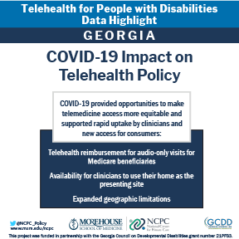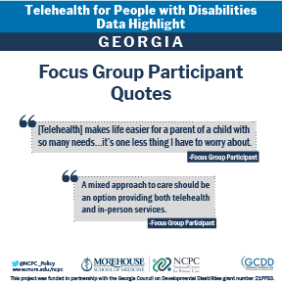

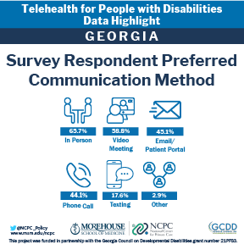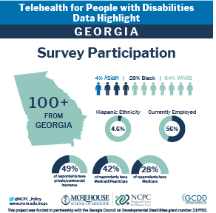
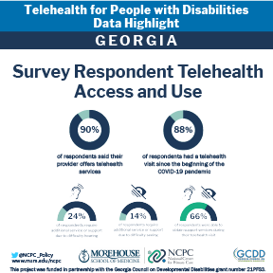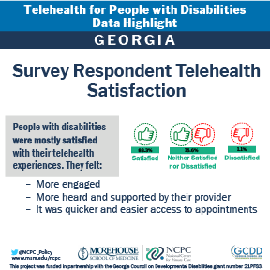

Main Social Media Handles:
 | National Center for Primary Care, Health Policy Division | Morehouse School of Medicine | Georgia Council on Developmental Disabilities
Twitter | @NCPC_Policy | @MSMEDU | @georgiacouncil
Facebook | @MSMNCPC | @MorehouseSchoolofMedicine | @GeorgiaCouncil onDevelopmentalDisabilities
LinkedIn | Morehouse School of Medicine National Center for Primary Care | Morehouse School of Medicine | Georgia Council on Developmental Disabilities
Instagram |  | @morehouseschoolofmedicine | @gaddcouncil

Additional Resources:
If you’d like to learn more about findings from the Telehealth for People with Disabilities Study, please visit: [LINK]

